
GROUP ASSIGNMENT

Tiffany & Co.: The LVMH Proposal

Nitin Narayanaswamy Rishav Jhaveri
Yash Mahavir Khanter
Contents
Executive Summary 3
Strategic Analysis: Advantages and Disadvantages of the Merger 4
Valuation Analysis 7
Key Value Drivers 9
Negotiation Strategy and Recommendations 10
Conclusion 11

Executive Summary
Tiffany & Co.'s Board of Directors faces a pivotal decision regarding LVMH's potential acquisition proposal. After conducting a comprehensive valuation analysis using multiple methodologies, we recommend that the Board enter negotiations with LVMH while maintaining a strong negotiating position to maximize shareholder value.
Our discounted cash flow analysis indicates that Tiffany's intrinsic stand-alone value is $105.23 per share, based on conservative assumptions including a 7.11% weighted average cost of capital and a 2.5% terminal growth rate. This valuation represents a 15% premium to the current stock price of $91.58, which has fallen 35% from its 52-week high of $140 due to temporary headwinds including US-China trade tensions, Hong Kong protests, and a strong dollar impacting tourist spending.
When we expand our analysis to include comparable company and precedent transaction methodologies, the weighted average valuation across all approaches yields $106.95 per share. The valuation range spans from a conservative $72 per share in pessimistic scenarios to an optimistic $217 per share under favourable assumptions. Notably, the 2011 Bulgari acquisition, where LVMH paid 29 times EBIT and a 60% premium to market price, provides a strong precedent that would support a valuation of approximately $175 per share for Tiffany.
From a strategic perspective, this merger presents compelling logic for both parties, though the benefits appear more critical for LVMH. For Tiffany, the acquisition would provide access to LVMH's unparalleled global distribution network, particularly in Europe where Tiffany currently generates only 11% of its revenue compared to 45% from the Americas. The company would benefit from operational synergies including gross margin improvements of 5% in Europe and 4% in other regions, enhanced working capital efficiency, and the financial strength to accelerate its turnaround plan without capital constraints.
For LVMH, acquiring Tiffany would double its watches and jewellery segment from 9% to approximately 18% of total revenue, finally providing the scale needed to compete effectively with Richemont, which currently leads the hard luxury market with an 18.2% share. More importantly, LVMH would acquire the most iconic American luxury brand with 182 years of heritage, instant access to 11% global jewellery market share, and 321 prime retail locations worldwide. The strategic imperative for LVMH is clear: Tiffany represents perhaps the last opportunity to acquire a major independent luxury jeweller with global brand recognition.
Given this asymmetry in strategic benefits and Tiffany's current valuation discount, we recommend the Board adopt an aggressive negotiation stance. We suggest demanding a minimum acceptable price of $125 per share, representing a 35% premium to current trading levels. Our target settlement range is $135 to $140 per share, which would represent a 47% to 53% premium and properly compensate shareholders for both Tiffany's intrinsic value and the substantial synergies LVMH would realize. The Board should open negotiations at $150 per share to establish a strong anchor point and should be prepared to walk away if LVMH offers less than $125 per share.

To maximize leverage, the Board should insist on a 45-day go-shop period to explore competing offers from potential bidders including Richemont, which may act defensively to maintain its market leadership; Kering, which seeks to expand its jewellery presence; or financial buyers like Berkshire Hathaway, which could offer greater operational independence. Any transaction should be structured as an all-cash deal to provide certainty of value, with appropriate protections including a 3-4% breakup fee and contractual guarantees preserving Tiffany's brand autonomy and heritage.
The current market environment creates a unique window where Tiffany's temporary challenges provide LVMH with an opportunistic entry point, while Tiffany's improving fundamentals and scarcity value as the last major independent American luxury jeweler justify a substantial premium. Time is of the essence, as continued execution of Tiffany's turnaround plan and normalization of market conditions will only strengthen the company's negotiating position. With careful execution, the Board can achieve a transaction that maximizes shareholder value while ensuring the preservation and enhancement of one of America's most iconic luxury brands.

Strategic Analysis: Advantages and Disadvantages of the Merger

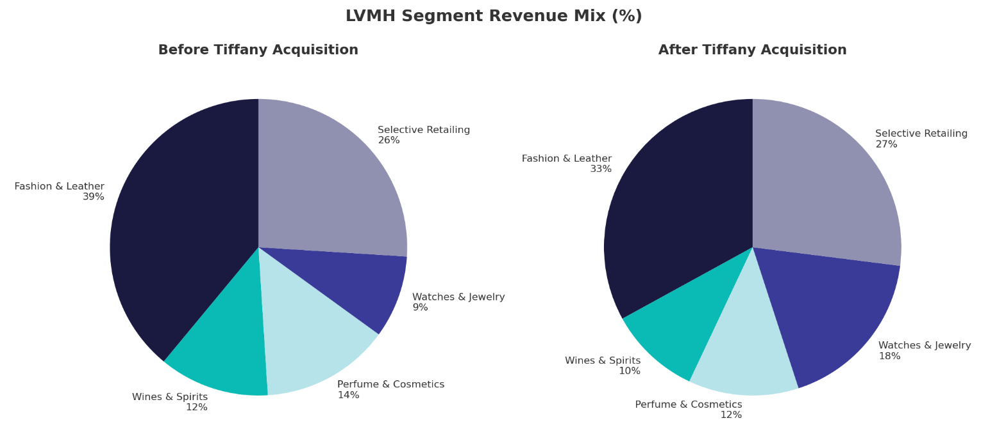

The proposed acquisition of Tiffany & Co. by LVMH represents a transformative opportunity for both companies in the global luxury goods market. While the strategic rationale is compelling, the merger presents both significant benefits and notable risks that must be carefully evaluated. Our analysis reveals asymmetric advantages favoring LVMH, which supports Tiffany's position to negotiate aggressively for a substantial premium.

Strategic Benefits and Risks Analysis
For Tiffany & Co.
Advantages | Description | Impact
Global Distribution Access | Access to LVMH’s European network where Tiffany only has 11% revenue share vs. 45% in Americas | Revenue growth +12pp in Europe (2020–2022)
Financial Resources | LVMH’s A+ credit rating and €46.8B revenue base funds expansion without capital constraints | Enables $282M Fifth Avenue renovation and China expansion
Operational Synergies | Procurement scale, shared back-office, distribution efficiencies | Gross margin +5% (Europe), +4% (other); Working capital efficiency +50%
China Market Expertise | Leverage LVMH’s infrastructure in fastest-growing luxury market | Access to 46% of global luxury market by 2025
Brand Portfolio Benefits | Cross-selling opportunities while maintaining autonomy under decentralized model | Enhanced marketing reach across 75 brands

Disadvantages | Description | Risk
Loss of Independence | End of 182-year legacy as independent American jeweller | Potential dilution of unique American heritage and brand identity
Poor Timing | Stock at $91.58, down 35% from $140 high due to temporary headwinds | Selling at cyclical low before turnaround plan fully realized
Cultural Integration | American “accessible luxury” vs. European exclusivity philosophy | Risk of talent loss and brand positioning conflicts
Strategic Autonomy | Decision-making shifts to Paris despite autonomy promises | Loss of control over long-term strategy and investments

For LVMH
Advantages | Description | Impact
Hard Luxury Scale | Doubles watches & jewellery from 9% to ~18% of revenue | Direct challenge to Richemont’s 18.2% market leadership
American Heritage Brand | Only major US luxury jeweller with global recognition | Geographic diversification and authentic US market presence
Immediate Market Share | Tiffany’s established position and infrastructure | 11% global jewellery share and 321 prime retail locations
Proven Integration Model | Successful Bulgari acquisition provides playbook | Clear path to value creation and synergy realization

Disadvantages | Description | Risk
Premium Valuation | Must pay 30–50% premium in competitive environment | $120–140 per share vs. current $91.58 requires $14.6–17.1B
Macro Headwinds | Hong Kong protests, US–China trade war, strong USD | Near-term pressure on luxury spending and integration
Integration Complexity | 321 stores across multiple regions and channels | Execution risk on synergy realization
Competitive Response | Richemont, Kering may bid or retaliate | Bidding war or competitive actions in other markets
Strategic analysis
The analysis demonstrates clear strategic merit for the transaction, with LVMH gaining critical scale in hard luxury and Tiffany accessing resources for global expansion. However, the asymmetric benefits—LVMH's strategic imperative versus Tiffany's optionality—combined with Tiffany's temporarily depressed valuation, create substantial leverage for demanding a premium that reflects both intrinsic value and long-term potential. The Board should use this leverage to maximize shareholder value while ensuring appropriate protections for Tiffany's iconic brand heritage.

Valuation Analysis
Our comprehensive valuation analysis employs multiple methodologies to establish Tiffany's fair value range. The valuation football field chart below illustrates the wide range of potential values depending on the methodology and assumptions used.

Method | Low | Implied | High | Weights
DCF | $71.86 | $105.23 | $216.66 | 20%
EV/Revenue | $34.52 | $108.42 | $293.77 | 20%
EV/EBITDA | $47.49 | $94.62 | $233.51 | 20%
EV/EBIT | $62.88 | $135.00 | $515.40 | 20%
P/E | $36.55 | $91.48 | $134.69 | 20%
Weighted Average |  | $106.95 |  | 100%

Premium Analysis

Metric | Value
30% Premium over Implied Value/Share | $139
Shares Outstanding | 122M
Equity Value after Premium | $16,962M
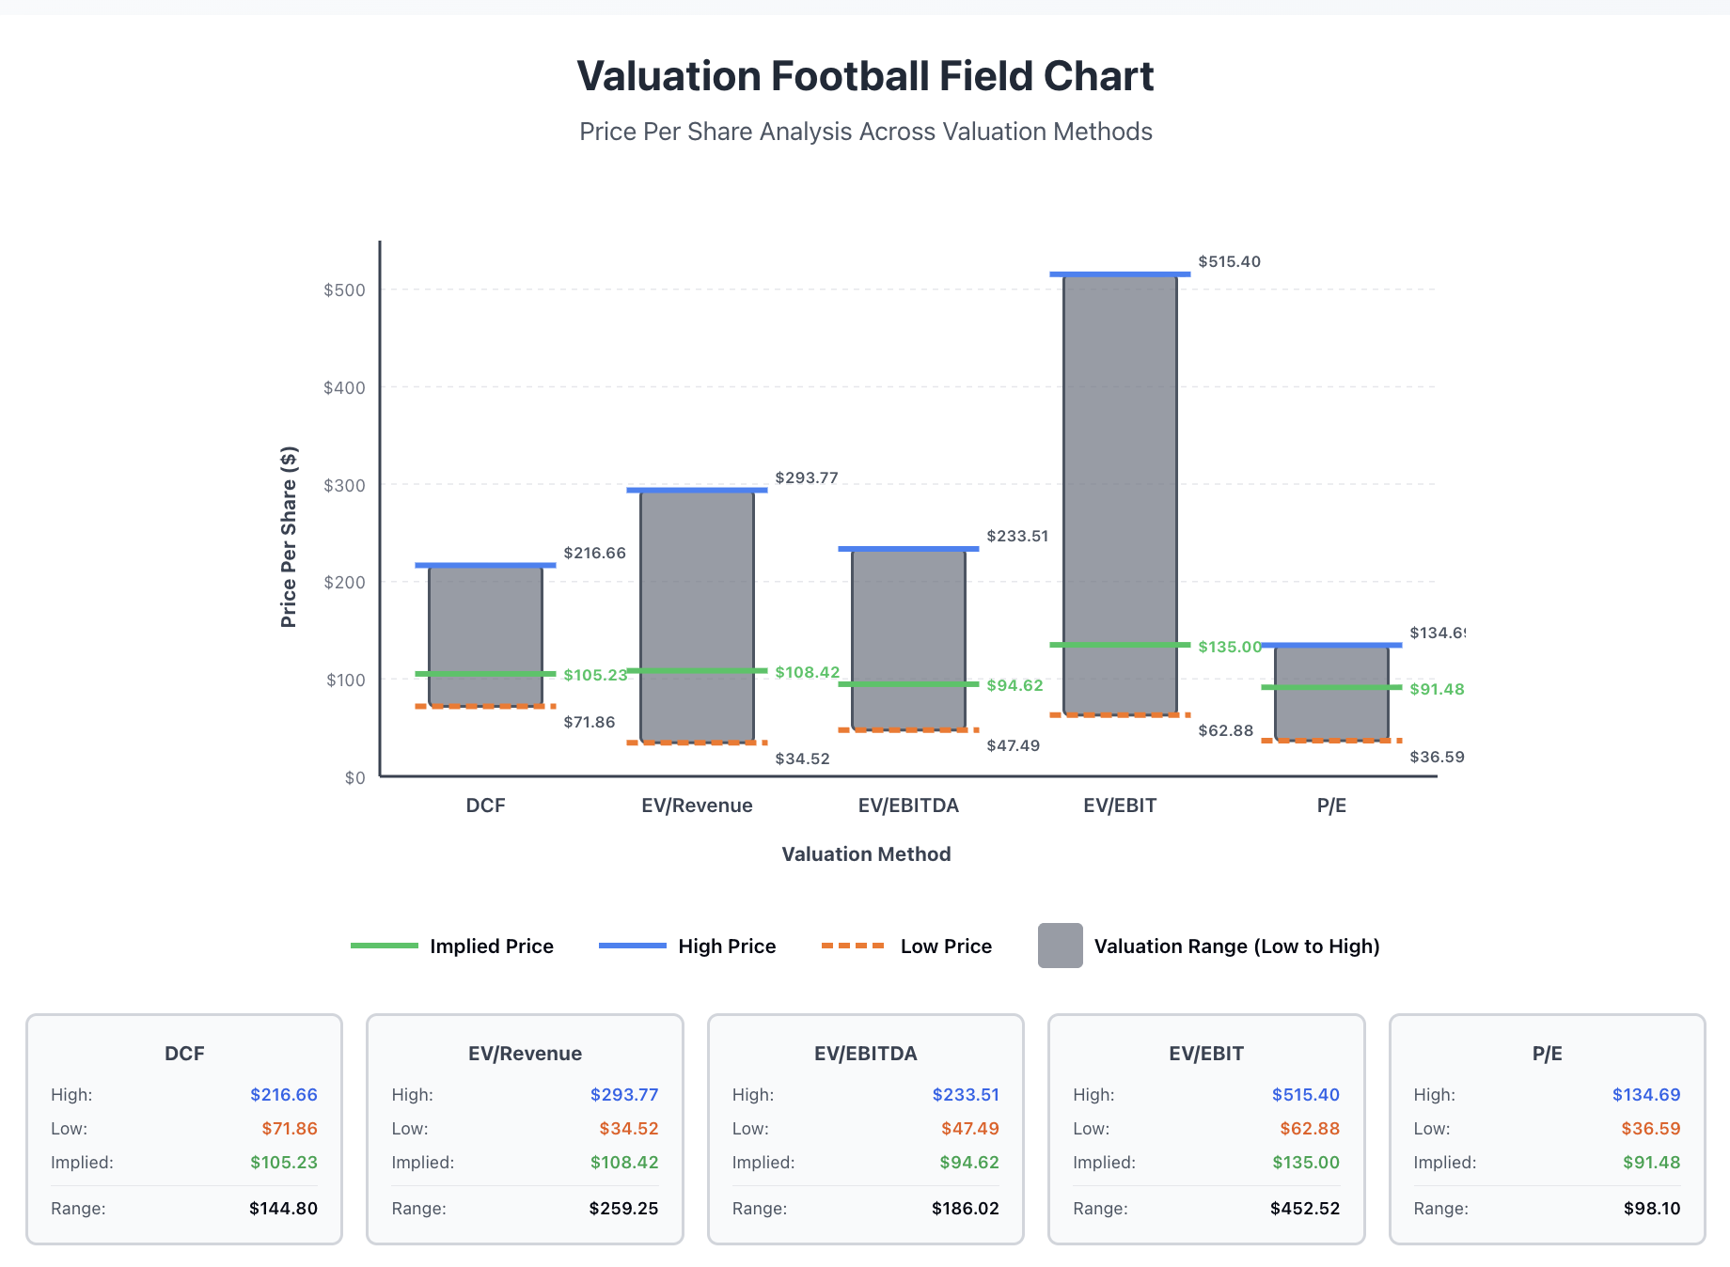
The valuation analysis reveals an extremely wide range from $34.52 to $515.40 per share, reflecting the uncertainty inherent in luxury goods valuation and the sensitivity to different methodologies. The most reliable range clusters between $71.86 and $216.66 per share, with the weighted average of all methodologies yielding $106.95 per share as our best estimate of Tiffany's intrinsic stand-alone value. This is notably higher than the current trading price of $91.58, suggesting the market is undervaluing Tiffany due to temporary headwinds.
Our DCF analysis, which we consider the most fundamental approach, values Tiffany at $105.23 per share based on conservative growth assumptions (4% Americas, 7% Asia Pacific), a WACC of 7.11% reflecting current market conditions, terminal growth of 2.5% aligned with GDP expectations, and detailed 8-year cash flow projections. The relative valuation methods show significant variation, with EV/Revenue ($108.42) and EV/EBIT ($135.00) suggesting higher values while EV/EBITDA ($94.62) and P/E ($91.48) suggest lower values, reflecting differences in profitability and growth expectations across comparable companies. The Bulgari acquisition precedent of 29x EBIT and 60% premium would imply a value well above $150 per share, providing strong support for aggressive negotiation.
Negotiation Implications
Based on this comprehensive analysis, we establish clear price targets for negotiations. The minimum acceptable price of $120 per share represents a modest 14% premium to intrinsic value, below which shareholders would be better off remaining independent. Our target price range of $135-140 per share represents a 26-31% premium to intrinsic value, fairly allocating synergy value between parties and aligning with the 30% premium benchmark of $139. The opening position should be $150+ per share to anchor negotiations at the upper end of the range, supported by the Bulgari precedent and high-end multiples while creating room for negotiation.
The football field visualization clearly shows that at the current trading price of $91.58, Tiffany is trading below its intrinsic value range. LVMH's expected offer must adequately compensate shareholders not only for this intrinsic value but also for the substantial synergies LVMH will realize, Tiffany's scarcity value as the last major independent luxury jeweler, and the loss of future upside from the turnaround plan. Any offer below $120 would transfer too much value to LVMH shareholders and should be rejected. The optimal outcome would be a negotiated price in the $135-140 range, which appropriately rewards Tiffany shareholders while still allowing LVMH to create value through the combination.

Key Value Drivers
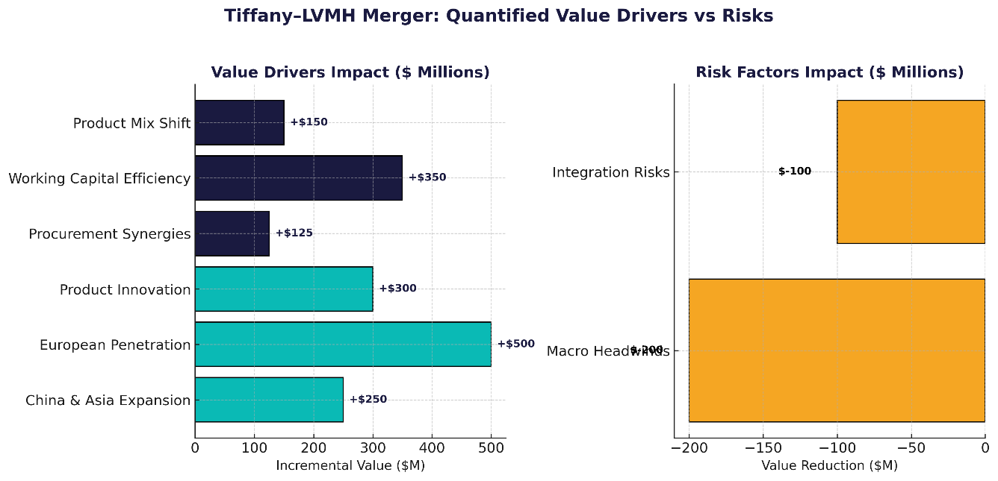
Revenue Growth Drivers
China and Asia Pacific Expansion: The most critical growth driver is China, where consumers will represent 46% of global luxury purchases by 2025. Tiffany has achieved double-digit growth for six consecutive quarters in the region. With LVMH's infrastructure, the projected 7% growth could accelerate to 10-12%, adding $200-300M in incremental revenue.
European Market Penetration: Europe is Tiffany's largest untapped opportunity, generating only 11% of revenue versus 45% from Americas. LVMH's distribution network could double European revenue from $504M to over $1B within five years through the projected 12 percentage point growth acceleration.
Product Innovation: Expanding the underpenetrated watches category leveraging LVMH's expertise, while modernizing the portfolio for millennials, could add 10-15% to revenue and create pricing power of 3-5% annually.

Margin Enhancement Drivers
Procurement Synergies: LVMH's scale in precious metals and diamonds would deliver gross margin improvements of 5% in Europe and 4% in other regions, generating $100-150M in additional annual gross profit.
Operational Efficiency: Working capital optimization improving turnover by 50% (from 1.46x to 2.2x) would free up $300-400M in cash. SG&A reduction from 45.6% to 45% of revenue through shared services would further enhance profitability.
Product Mix Shift: Focus on higher-margin diamond and gold jewelry versus silver, supported by experiential retail initiatives like the Blue Box Café, enables premium positioning and sustained price increases.
Risk Factors
Macro Headwinds: US-China trade tensions, Hong Kong protests (affecting 5% of revenue), and strong USD impacting tourist spending pose near-term challenges. However, geographic diversification through the merger mitigates concentration risk.
Integration Risk: Cultural differences between American accessible luxury and European exclusivity, potential brand dilution, and talent retention challenges must be managed through LVMH's proven decentralized model.

Negotiation Strategy and Recommendations
Price Positioning
Based on our valuation of $105-107 per share stand-alone plus $20-25 in synergies, we recommend opening negotiations at $150 per share to anchor high, targeting a settlement of $135-140 per share, with a walk-away point below $120. This pricing reflects Tiffany's intrinsic value, scarcity premium as the last major independent jeweler, and the substantial synergies LVMH will realize.
Negotiation Leverage
Tiffany holds significant leverage as LVMH needs this acquisition to compete with Richemont in hard luxury, where it currently has only 9% revenue exposure versus Richemont's 18% market share. The Bulgari precedent of 29x EBIT supports aggressive pricing. Additionally, Tiffany's temporary headwinds (Hong Kong protests, trade tensions) are cyclical rather than structural, and improving conditions will only strengthen the negotiating position.
Key Deal Terms
The transaction must be all-cash with no financing contingencies. Essential protections include a 45-day go-shop period to solicit competing offers, brand autonomy guarantees with headquarters remaining in New York, and retention packages for key executives. A reverse breakup fee of 6-8% should protect against LVMH failing to close.
Alternative Options
If LVMH's offer falls below $120, the Tiffany Board should pursue alternatives including remaining independent to execute the turnaround plan showing early success, engaging alternative acquirers (Richemont, Kering, Berkshire Hathaway), or exploring strategic partnerships that provide growth capital while maintaining independence.
Board Actions
Form a special committee immediately, engage two financial advisors for fairness opinions, and prepare to actively negotiate. Refuse due diligence below $130 per share and be prepared to walk away if fair value isn't offered. Time favors Tiffany—every quarter of successful execution strengthens the negotiating position.
Recommendation
Enter negotiations from strength, demanding a price that reflects both intrinsic value and strategic importance. A transaction at $135-140 per share with appropriate protections represents a successful outcome. However, be prepared to reject inadequate offers, as Tiffany's improving fundamentals and scarcity value will only increase over time.

Conclusion
Tiffany & Co. faces a critical decision regarding LVMH's potential acquisition proposal. Our analysis establishes Tiffany's intrinsic value at $105-107 per share, well above the current trading price of $91.58. With identified synergies worth $20-25 per share, the total value reaches $125-132 per share before any control premium.
The strategic logic is clear but asymmetric—LVMH needs Tiffany to compete in hard luxury, while Tiffany can succeed independently. As the last major independent luxury jeweler, Tiffany has significant negotiating leverage that must be fully utilized.
The Board should demand a minimum of $125 per share, targeting $135-140 per share. Any offer below $125 should be rejected. Time favors Tiffany as temporary headwinds will normalize and the turnaround plan gains traction. The Board should immediately form a special committee, engage advisors, and prepare for negotiations while exploring alternatives. Whether through a fair-value acquisition or remaining independent, multiple paths exist to maximize shareholder value.
The decision is not whether to sell, but at what price. Below $125 per share, Tiffany is worth more.

